Monday 11th May 2020
Free Reading | Guidance on Class Page at https://www.oaklandsprimary.co.uk/
Activelearn Maths | Pesky Pests  Or  Reading and writing amounts of money  Counting back in 1s, 10s and 100s  Times-tables up to 10 × 10  Mentally adding two 2-digit numbers  Driving Test 13  Have a go at Smack the Shack 4.2a, b and c when you finish!
Spelling List | Dictionary Definitions  Look up each word in a dictionary (preferably a hard copy rather than online). Write down the definition.
Giglets
    Read this story. | 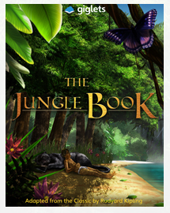  Read Chapter 2 again, then answer the Higher Order Thinking Questions relating to that chapter.
History Activity | https://www.bbc.co.uk/bitesize/articles/zv67mfr  
Weekly Task
Investigate the different birds that you can find in your area.

I’m sure you’ve all heard and seen the wildlife that is around at this time of year, especially the birds. I’d love to investigate what type of birds are in your area?

Can you identify them?
Can you create artwork involving them?
Can you research them, using  on Hwb?
Can you do something to help them make your garden their home?
Can create something that keeps them away from areas where they may damage, like a vegetable patch?
Can you mimic their calls using your voice or something else?

I’d like to see photos, documents or presentations of what you’re doing! On Friday, we might be able to send our findings to the RSPB (The Royal Society for the Protection of Birds) to help with their research!

