Tuesday 12th May 2020
Free Reading | Guidance on Class Page at https://www.oaklandsprimary.co.uk/
Activelearn Maths | Problem Solving Investigations  Complete:  Wonderful 1089!  Or  Star of change  Work through these on your own or with an adult. Sometimes a ‘Problem Solving Investigation’ will suggest you print off cards or a board. If you cannot do this, improvise by creating your own.
Spelling List | Sentences - Write sentences that contain the words in your list.
Giglets
  Complete the reading test questions of   | 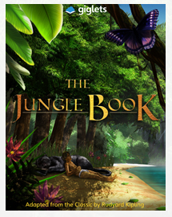  Read Chapter 3 again, then answer the Higher Order Thinking Questions relating to that chapter.
Geography Activity | https://www.bbc.co.uk/bitesize/articles/zkm2xyc  
Weekly Task
Investigate the different birds that you can find in your area.

I’m sure you’ve all heard and seen the wildlife that is around at this time of year, especially the birds. I’d love to investigate what type of birds are in your area?

Can you identify them?
Can you create artwork involving them?
Can you research them, using  on Hwb?
Can you do something to help them make your garden their home?
Can create something that keeps them away from areas where they may damage, like a vegetable patch?
Can you mimic their calls using your voice or something else?

I’d like to see photos, documents or presentations of what you’re doing! On Friday, we might be able to send our findings to the RSPB (The Royal Society for the Protection of Birds) to help with their research!

