Friday 15th May 2020
Free Reading | Guidance on Class Page at https://www.oaklandsprimary.co.uk/
Activelearn Maths PSI | Problem Solving Investigation  Pink or blue?  Or  Foodie fractions  Work through these on your own or with an adult. Sometimes a ‘Problem Solving Investigation’ will suggest you print off cards or a board. If you cannot do this, improvise by creating your own.
Spelling List | Written test  Ask someone to test you on spelling the words in your Spelling List. Write them on paper, then check them with an adult.
Giglets | Using the book review template that I’ve uploaded, write a review of the book that you read.
  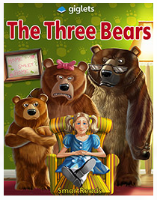 | 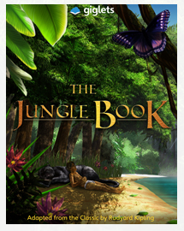
Art & Design Activity | https://www.bbc.co.uk/bitesize/articles/zjgj7nb  
Weekly Task
Investigate the different birds that you can find in your area.

I’m sure you’ve all heard and seen the wildlife that is around at this time of year, especially the birds. I’d love to investigate what type of birds are in your area?

Can you identify them?
Can you conduct an investigation to see what bird you see the most of?
Can you create artwork involving them?
Can you research them, using  on Hwb?
Can you do something to help them make your garden their home?
Can create something that keeps them away from areas where they may damage, like a vegetable patch?
Can you mimic their calls using your voice or something else?

I’d like to see photos, documents or presentations of what you’re doing! On Friday, we might be able to send our findings to the RSPB (The Royal Society for the Protection of Birds) to help with their research!

