Friday 12th June 2020
Free Reading | Guidance on Class Page at https://www.oaklandsprimary.co.uk/
Activelearn Maths  1.12 | Marching Madness  Or  Adding three small numbers  Halving 2-digit numbers  7 times-table  Mental division  Driving Test 19
Spelling List | Written test  Ask someone to test you on spelling the words in your Spelling List. Write them on paper, then check them with an adult.
Giglets | 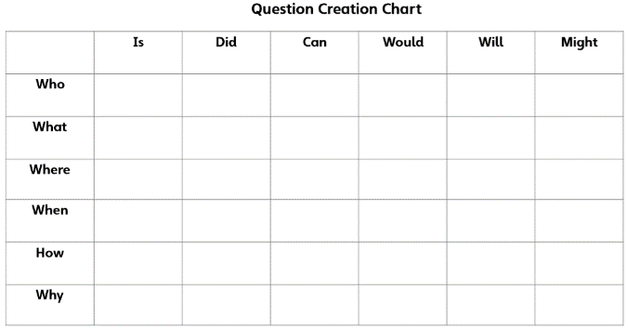  Using the Question Creation Chart, ask a question about the facts that you read about.  Post your question on Microsoft Teams (as a comment) and see if you can answer someone else’s question.
  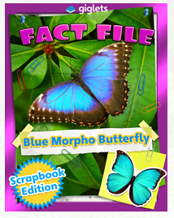 | 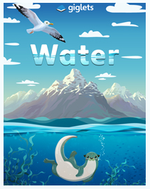 | 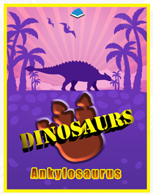
Art & Design Activity | https://www.bbc.co.uk/bitesize/articles/zxr3trd  
Weekly Activity | I have assigned you all Non-Chronological texts as your books on giglets this week.  After reading them, have a little think about how a Non-Chronological text is different to a story?  Read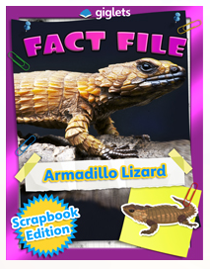 on giglets.  Can you spot any of these features?  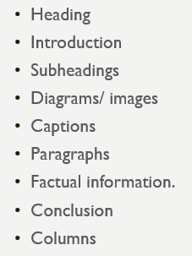  This week, I’d like you to conduct your own research on an animal of your choice then show your research as a non-chronological text.  Present your research by  - Using pen and paper, you could draw the pictures and diagrams that you wish to include.  - Using just2easy  - Creating a ppt presentation  - Creating a fact file  Good luck!

