Thursday 21st May 2020
Free Reading | Guidance on Class Page at https://www.oaklandsprimary.co.uk/
Activelearn Maths | Bubble Burst
Spelling List | Verbal test  Ask someone to test you on spelling the words in your Spelling List. Do this by saying the letters back to the person, not writing them down. If you find any one the words tricky, it may be useful to make a rhyme / song of the letters in the correct order
Giglets | Higher Order Thinking Skills  Answer the questions about the poem that you were allocated.
  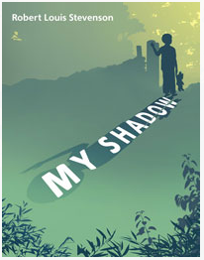 | 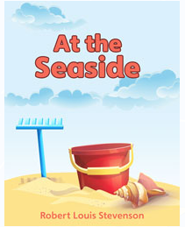 | 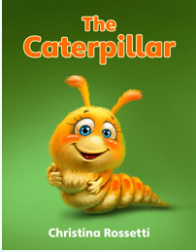
Computing Activitiy | https://www.bbc.co.uk/bitesize/articles/zbk6pg8  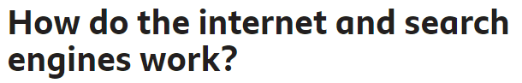
Weekly Task

Siwmae pawb!

Complete as many activities as possible of Seren a Sbarc’s 30 challenges! You will find the ppt (with links) on our Microsoft Teams page and I have placed screenshots below.

I would love to see videos / photos of what you're doing, either uploaded onto Teams or emailed to me directly!


