Thursday 4th June 2020
Free Reading | Guidance on Class Page at https://www.oaklandsprimary.co.uk/
Activelearn Maths | Beat the Bubble  Or  Toucan Team
Spelling List | Verbal test  Ask someone to test you on spelling the words in your Spelling List. Do this by saying the letters back to the person, not writing them down. If you find any one the words tricky, it may be useful to make a rhyme / song of the letters in the correct order
Giglets | Higher Order Thinking Skills  Answer the questions about the book that you were allocated.
  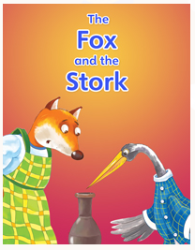 | 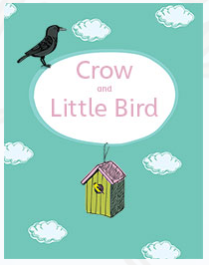 | 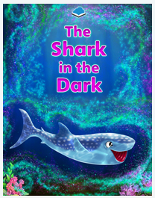
Welsh Activity | Watch the video and have a go at the activities on this webpage.  https://www.bbc.co.uk/bitesize/topics/zs7t97h/articles/zsf9tv4
Weekly Activity | When you get an opportunity to work with an adult, read and discuss this poster.  Have a go at the activity, remembering:  - You can design your logo by hand using a pencil / pen on paper.  - You can design your logo online using just2easy, JIT5 Paint, or any other paint program.  - The more designs you create, the better your finished product will be.  - I always want to see what you’re doing, upload your finished logos to Microsoft Teams!  

