Wednesday 10th June 2020
Free Reading | Guidance on Class Page at https://www.oaklandsprimary.co.uk/
Activelearn Maths | Problem Solving Investigations  Complete:  Magical square decimals  Or  Sock doubles  Work through these on your own or with an adult. Sometimes a ‘Problem Solving Investigation’ will suggest you print off cards or a board. If you cannot do this, improvise by creating your own.
Spelling List | Handwriting Practise writing the sentences that you wrote yesterday in your neatest handwriting.
Giglets | Find out more about the topics that you learned about in your book using  (find this on the hwb website).  Can you present your extra learning in a different way (presentation, animation, etc…)?
  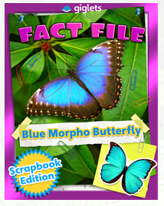 | 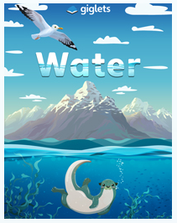 | 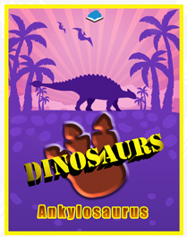
Science Activity | https://www.bbc.co.uk/bitesize/articles/zm9jmyc
Weekly Activity | I have assigned you all Non-Chronological texts as your books on giglets this week.  After reading them, have a little think about how a Non-Chronological text is different to a story?  Read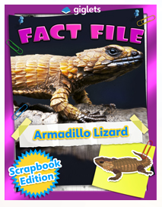 on giglets.  Can you spot any of these features?  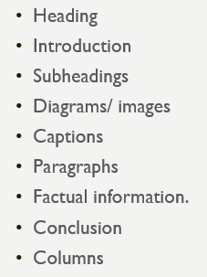  This week, I’d like you to conduct your own research on an animal of your choice then show your research as a non-chronological text.  Present your research by  - Using pen and paper, you could draw the pictures and diagrams that you wish to include.  - Using just2easy  - Creating a ppt presentation  - Creating a fact file  Good luck!

