
Magical square decimals

4 | 3 | 8
9 | 5 | 1
2 | 7 | 6

- Look at the magic square.
Create a two-digit number by starting with any number on the square and moving either left or right, down or up (including diagonally).
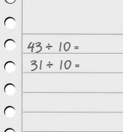
- Divide the number by 10 to get a one-place decimal number.
- How many numbers between 1 and 6 can you make in this way?

How can you be certain that you have found them all?
Can you demonstrate to someone else that you have got all the possibilities?

