
Sock doubles

- Every player needs a track.
Take it in turns in your teams to throw the rolled up socks onto the target board.
If the socks land on it, double the number in that square (because there are two socks). Ring the answer on your track.

- Carry on taking turns until one team rings five different numbers.
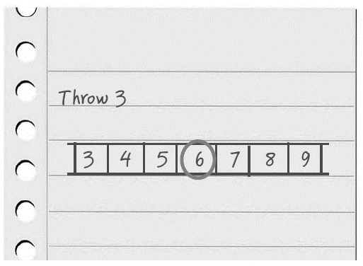
What do you notice about the numbers you have ringed?
Can you see a pattern?
What are these numbers called?
Is it possible to ring other numbers on the track when playing this game?
Why/why not?


Challenge
Design a game called Sock halves. The answers on the track are 1, 2, 3, 4 and 5.
On the matching target board, every number when halved gives an answer on the new track.



