Tuesday 2nd June 2020
Free Reading | Guidance on Class Page at https://www.oaklandsprimary.co.uk/
Activelearn Maths | Mental multiplication  Counting on and back in halves and quarters  Dividing by 6  Counting on and back in 1s and 10s  Driving Test 16  Or  Mushroom Mayhem
Spelling List | Sentences - Write sentences that contain the words in your list.
Giglets | Answer the Reading Test Questions of the book that you read.
   | 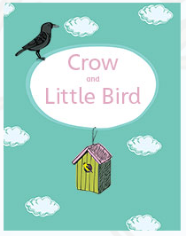 | 
Geography Activity | https://www.bbc.co.uk/bitesize/articles/zbwckmn  
Weekly Activity | When you get an opportunity to work with an adult, read and discuss this poster.  Have a go at the activity, remembering:  - You can design your logo by hand using a pencil / pen on paper.  - You can design your logo online using just2easy, JIT5 Paint, or any other paint program.  - The more designs you create, the better your finished product will be.  - I always want to see what you’re doing, upload your finished logos to Microsoft Teams!  

