Tuesday 9th June 2020
Free Reading | Guidance on Class Page at https://www.oaklandsprimary.co.uk/
Activelearn Maths  1.10 | Finding numbers with common factors  Subtracting 2-digit numbers  Rounding 3- and 4-digit numbers  Finding equivalent fractions  Driving Test 18  Or  Starfish Strike
Spelling List | Sentences - Write sentences that contain the words in your list.
Giglets | Answer the Reading Test Questions of the book that you read.
  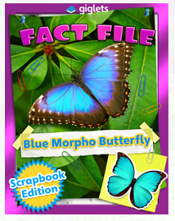 | 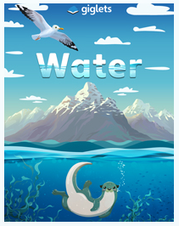 | 
Activity | https://www.bbc.co.uk/bitesize/articles/z4qfbwx  
Weekly Activity | I have assigned you all Non-Chronological texts as your books on giglets this week.  After reading them, have a little think about how a Non-Chronological text is different to a story?  Read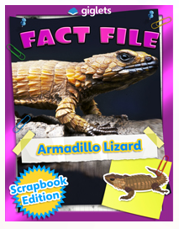 on giglets.  Can you spot any of these features?  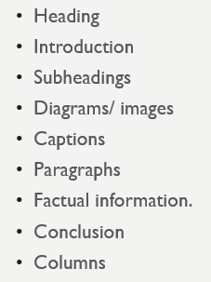  This week, I’d like you to conduct your own research on an animal of your choice then show your research as a non-chronological text.  Present your research by  - Using pen and paper, you could draw the pictures and diagrams that you wish to include.  - Using just2easy  - Creating a ppt presentation  - Creating a fact file  Good luck!

