Wednesday 3rd June 2020
Free Reading | Guidance on Class Page at https://www.oaklandsprimary.co.uk/
Activelearn Maths | Problem Solving Investigations  Complete:  Race to 200  Or  Square tens  Work through these on your own or with an adult. Sometimes a ‘Problem Solving Investigation’ will suggest you print off cards or a board. If you cannot do this, improvise by creating your own.
Spelling List | Handwriting Practise writing the sentences that you wrote yesterday in your neatest handwriting.
Giglets | Create an animation of this story using , then .
  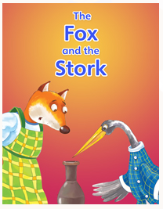 | 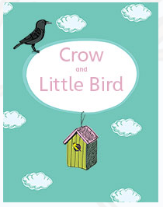 | 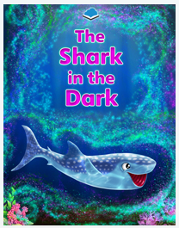
Activity | https://www.bbc.co.uk/bitesize/articles/zhnny9q  
Weekly Activity | When you get an opportunity to work with an adult, read and discuss this poster.  Have a go at the activity, remembering:  - You can design your logo by hand using a pencil / pen on paper.  - You can design your logo online using just2easy, JIT5 Paint, or any other paint program.  - The more designs you create, the better your finished product will be.  - I always want to see what you’re doing, upload your finished logos to Microsoft Teams!  

