Monday 8th June 2020
Free Reading | Guidance on Class Page at https://www.oaklandsprimary.co.uk/
Activelearn Maths  1.9 | Sea-shack Smash  Or  Marching Madness
Spelling List | Dictionary Definitions  Look up each word in a dictionary (preferably a hard copy rather than online). Write down the definition.
Giglets | Read the books that have been assigned to you on giglets.
  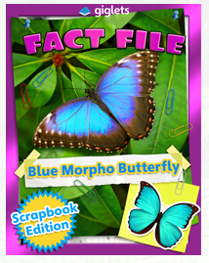 | 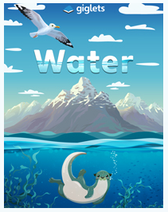 | 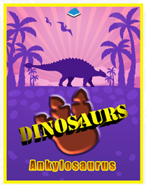
History Activity | https://www.bbc.co.uk/bitesize/articles/ztryxbk  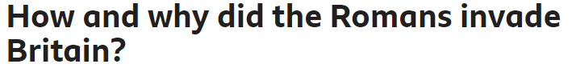
Weekly Activity | I have assigned you all Non-Chronological texts as your books on giglets this week.  After reading them, have a little think about how a Non-Chronological text is different to a story?  Read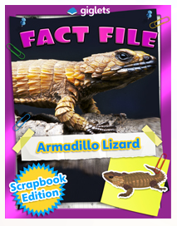 on giglets.  Can you spot any of these features?  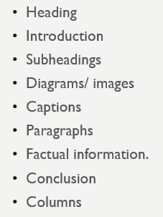  This week, I’d like you to conduct your own research on an animal of your choice then show your research as a non-chronological text.  Present your research by  - Using pen and paper, you could draw the pictures and diagrams that you wish to include.  - Using just2easy  - Creating a ppt presentation  - Creating a fact file  Good luck!

