Thursday 11th June 2020
Free Reading | Guidance on Class Page at https://www.oaklandsprimary.co.uk/
Activelearn Maths  1.11  4.9 | Hedgehog Hurry  Or  Hailstone Hullabaloo
Spelling List | Verbal test  Ask someone to test you on spelling the words in your Spelling List. Do this by saying the letters back to the person, not writing them down. If you find any one the words tricky, it may be useful to make a rhyme / song of the letters in the correct order
Giglets | Higher Order Thinking Skills  Answer the questions about the book that you were allocated.
  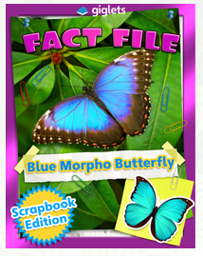 |  | 
Welsh Activity | Watch the video and have a go at the activities on this webpage. We haven’t learned about some of the Welsh language in the video, but I know that you’ll recognise a lot, and be able to work out more!  https://www.bbc.co.uk/bitesize/topics/zpjxcj6/articles/z98tcj6
Weekly Activity | I have assigned you all Non-Chronological texts as your books on giglets this week.  After reading them, have a little think about how a Non-Chronological text is different to a story?  Read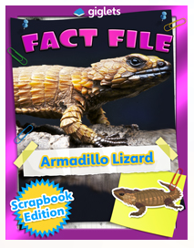 on giglets.  Can you spot any of these features?  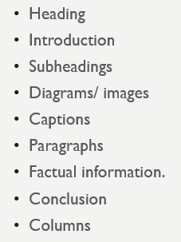  This week, I’d like you to conduct your own research on an animal of your choice then show your research as a non-chronological text.  Present your research by  - Using pen and paper, you could draw the pictures and diagrams that you wish to include.  - Using just2easy  - Creating a ppt presentation  - Creating a fact file  Good luck!

