Friday 22nd May 2020
Free Reading | Guidance on Class Page at https://www.oaklandsprimary.co.uk/
Activelearn Maths | Diamond Demolition  Or  Robot Revenge
Spelling List | Written test  Ask someone to test you on spelling the words in your Spelling List. Write them on paper, then check them with an adult.
Giglets | 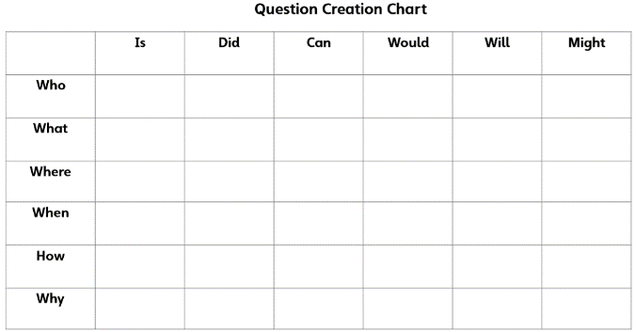  Using the Question Creation Chart, ask a question about the poem you read.  Post your question on Microsoft Teams and see if you can answer someone else’s question.
  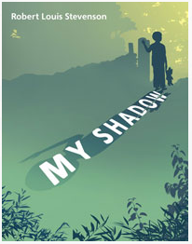 | 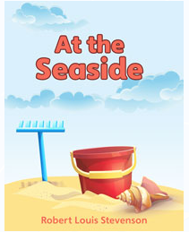 | 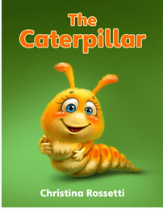
Music Activity | https://www.bbc.co.uk/bitesize/articles/z6bpf4j  
Weekly Task

Siwmae pawb!

Complete as many activities as possible of Seren a Sbarc’s 30 challenges! You will find the ppt (with links) on our Microsoft Teams page and I have placed screenshots below.

I would love to see videos / photos of what you're doing, either uploaded onto Teams or emailed to me directly!


