Monday 18th May 2020
Free Reading | Guidance on Class Page at https://www.oaklandsprimary.co.uk/
Activelearn Maths | Multiplying and dividing by 10 and 100  Bonds to 100QM  Using operations to make numbers  Mental multiplication  Driving Test 15  Near and far
Spelling List | Dictionary Definitions  Look up each word in a dictionary (preferably a hard copy rather than online). Write down the definition.
Giglets | Read the poems that have been assigned to you on giglets.
   | 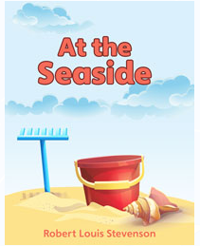 | 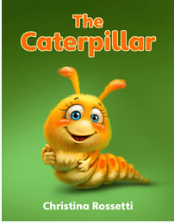
History Activity | https://www.bbc.co.uk/bitesize/articles/znjr92p  
Weekly Task

Siwmae pawb!

Complete as many activities as possible of Seren a Sbarc’s 30 challenges! You will find the ppt (with links) on our Microsoft Teams page and I have placed screenshots below.

I would love to see videos / photos of what you're doing, either uploaded onto Teams or emailed to me directly!


