Monday 1st June 2020
Free Reading | Guidance on Class Page at https://www.oaklandsprimary.co.uk/
Activelearn Maths  1.6 & 4.6 | Robot Revenge  Or  Clam Collector
Spelling List | Dictionary Definitions  Look up each word in a dictionary (preferably a hard copy rather than online). Write down the definition.
Giglets | Read the books that have been assigned to you on giglets.
  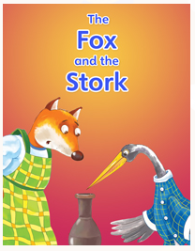 | 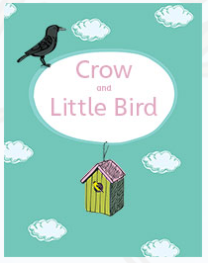 | 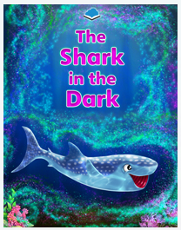
History Activity | https://www.bbc.co.uk/bitesize/articles/zrv4dty  
Weekly Activity | When you get an opportunity to work with an adult, read and discuss this poster.  Have a go at the activity, remembering:  - You can design your logo by hand using a pencil / pen on paper.  - You can design your logo online using just2easy, JIT5 Paint, or any other paint program.  - The more designs you create, the better your finished product will be.  - I always want to see what you’re doing, upload your finished logos to Microsoft Teams!  

