Tuesday 19th May 2020
Free Reading | Guidance on Class Page at https://www.oaklandsprimary.co.uk/
Activelearn Maths | Problem Solving Investigations  Complete:  Make it equal  Or  Tremendous tiles  Work through these on your own or with an adult. Sometimes a ‘Problem Solving Investigation’ will suggest you print off cards or a board. If you cannot do this, improvise by creating your own.
Spelling List | Sentences - Write sentences that contain the words in your list.
Giglets | Answer the Reading Test Questions of the poem that you read.
  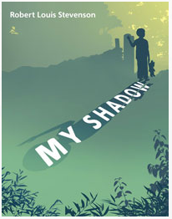 | 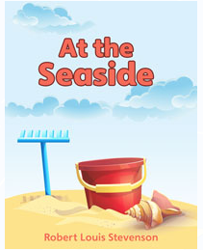 | 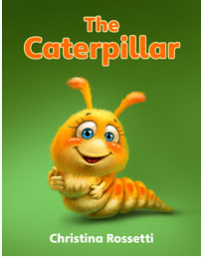
Geography Activity | https://www.bbc.co.uk/bitesize/articles/zdqybdm  
Weekly Task

Siwmae pawb!

Complete as many activities as possible of Seren a Sbarc’s 30 challenges! You will find the ppt (with links) on our Microsoft Teams page and I have placed screenshots below.

I would love to see videos / photos of what you're doing, either uploaded onto Teams or emailed to me directly!


