Friday 5th June 2020
Free Reading | Guidance on Class Page at https://www.oaklandsprimary.co.uk/
Activelearn Maths | Toucan Team  Or  Writing 4- and 5-digit numbers in figures  Adding to make the next pound  9 times-table  Finding one-quarter of a number (dividing by 4)  Driving Test 17
Spelling List | Written test  Ask someone to test you on spelling the words in your Spelling List. Write them on paper, then check them with an adult.
Giglets | 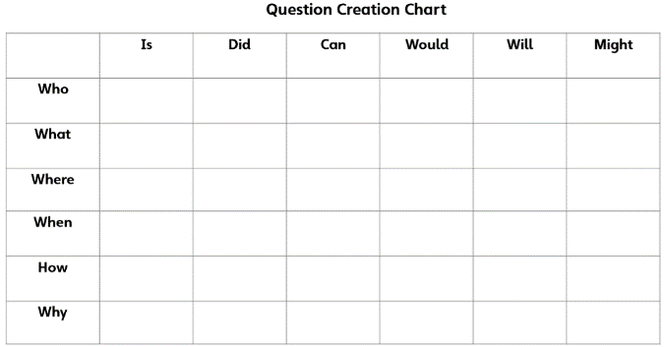  Using the Question Creation Chart, ask a question about the poem you read.  Post your question on Microsoft Teams and see if you can answer someone else’s question.
  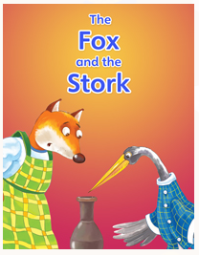 | 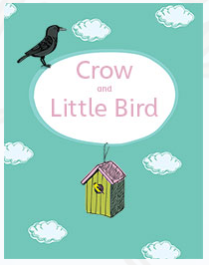 | 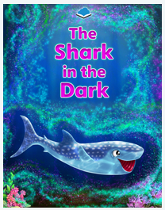
Design Technology Activity | https://www.bbc.co.uk/bitesize/articles/znrmt39  
Weekly Activity | When you get an opportunity to work with an adult, read and discuss this poster.  Have a go at the activity, remembering:  - You can design your logo by hand using a pencil / pen on paper.  - You can design your logo online using just2easy, JIT5 Paint, or any other paint program.  - The more designs you create, the better your finished product will be.  - I always want to see what you’re doing, upload your finished logos to Microsoft Teams!  

