Tuesday 7th July 2020
Free Reading | Guidance on Class Page at https://www.oaklandsprimary.co.uk/
Maths Learning | Complete assignment on Microsoft Teams
Spelling List | Complete assignment on Microsoft Teams
Literacy Assignment | Complete assignment on Microsoft Teams
Giglets | If you would ever like another book to read on giglets, post a message on Microsoft Teams with a genre of book you’d like.
  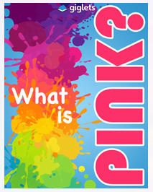 | 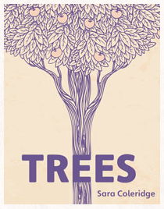 | 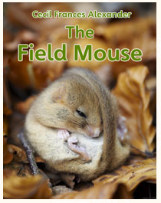
Activity | https://www.bbc.co.uk/bitesize/articles/zgt8bqt
Weekly Activity | https://www.youtube.com/watch?v=CyoWkZdGwzA  Use this map of Africa to create your own map, including the children from the book that live there.  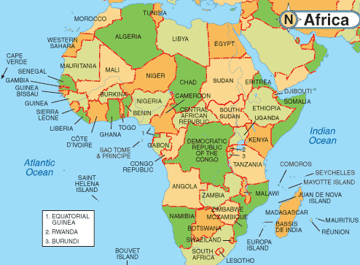  I have set this as an assignment with a document that you could use, or you could think of your own way of showing the countries of Africa on a map.

